**API Documentation**

**Introduction**

This document provides comprehensive documentation for the Collaborative Document Editor's backend services. It covers the REST API for standard operations and the WebSocket events used for real-time features. The system uses Firebase for user authentication and data persistence.

**Base URL**

* **Development**: http://localhost:5000/api

**Authentication Mechanism (Firebase Auth)**

The system uses Firebase Authentication to manage users. On the frontend, the client signs in using a standard Firebase method (e.g., email and password). Firebase then issues a JSON Web Token (JWT) ID token. This token must be included in the Authorization header for all protected API requests.

**Header Format :**

Authorization: Bearer <firebase_jwt_id_token>

The backend verifies this token using the Firebase Admin SDK on every request to authenticate the user and authorize access to resources.

**Socket Events (for real-time)**

The Socket connection is managed by Socket.IO and is crucial for real-time collaboration. The connection must be authenticated by passing the user's Firebase JWT ID token upon connection.

|  |  |  |  |
| --- | --- | --- | --- |
| **Event Name** | **Direction** | **Description** | **Payload Example** |
| join-document | Client → Server | Client requests to join a specific document's room to receive real-time updates. | { "documentId": "doc_123" } |
| leave-document | Client → Server | Client informs the server it is leaving a document's room. | { "documentId": "doc_123" } |
| content-change | Client → Server | A user sends their edits to the server to be broadcast to other collaborators. | { "documentId": "doc_123", "changes": {...} } |
| cursor-position | Client → Server | A user sends their cursor position to be shown to others in real-time. | { "documentId": "doc_123", "position": 245 } |
| user-joined | Server → Client | Notifies clients in a room that a new user has connected. | { "userId": "user_abc", "userName": "Jane Doe" } |
| user-left | Server → Client | Notifies clients that a user has disconnected. | { "userId": "user_abc" } |
| content-updated | Server → Client | Broadcasts document changes from one user to all others in the room. | { "changes": {...}, "sourceUser": "user_xyz" } |
| cursor-updated | Server → Client | Broadcasts a user's cursor position to all others. | { "userId": "user_abc", "position": 245 } |

**WebRTC Signaling Flow**

WebRTC is used for direct peer-to-peer communication (e.g., for voice/video chat). The WebSocket server acts as the signaling channel to help peers find and connect with each other. This flow is managed via WebSocket events.

1. **Offer**: When User A wants to connect to User B, User A's client sends a webrtc-offer event to the server, specifying User B as the target.
2. **Forward Offer**: The server forwards this offer to User B via a webrtc-offer-received event.
3. **Answer**: User B's client receives the offer and generates an answer, which it sends back to the server with a webrtc-answer event, targeting User A.
4. **Forward Answer**: The server forwards this answer to User A via a webrtc-answer-received event.
5. **ICE Candidates**: As both clients discover network candidates (ways to connect), they send webrtc-ice-candidate events to the server, which forwards them to the other peer.
6. **Connection**: Once the offer/answer exchange is complete and ICE candidates are shared, a direct WebRTC peer-to-peer connection is established.

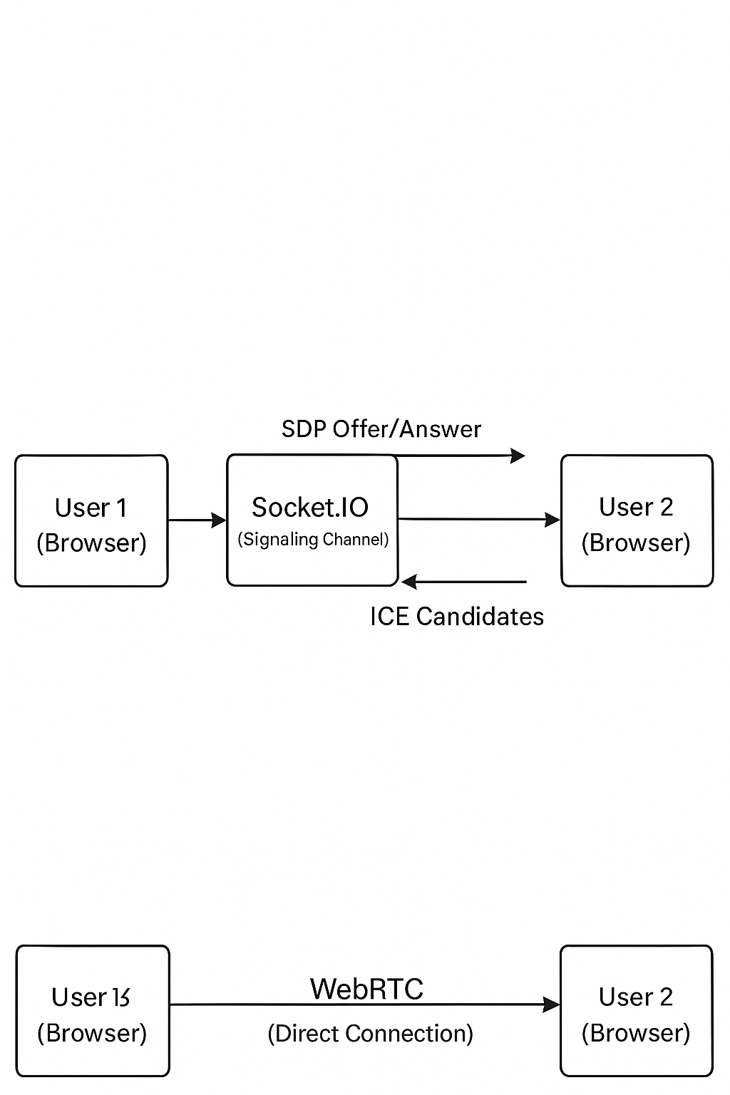

**API Routes**

The following are the custom backend REST API endpoints.

**Authentication**

**POST /auth/register**

* **Description**: Registers a new user in the Firebase system.
* **Request Method**: POST
* **Request Body**:

|  |  |  |
| --- | --- | --- |
| **Field** | **Type** | **Description** |
| email | string | The user's email address. Must be unique. |
| name | string | The user's full name. |
| password | string | The user's password (min. 6 characters). |

* **Response (201 Created)**: Returns a confirmation message, the new user object, and a session token.
* **Status Codes**:
  + 201: User created successfully.
  + 400: Bad request (e.g., invalid email, weak password).
  + 409: Conflict (email already exists).

**Documents**

**GET /documents**

* **Description**: Retrieves all documents accessible to the authenticated user.
* **Request Method**: GET
* **Response (200 OK)**: Returns an object containing an array of Document objects. See the [Data Models](https://www.google.com/search?q=%23data-models) section for the Document object structure.
* **Status Codes**:
  + 200: Success.
  + 401: Unauthorized.

**POST /documents**

* **Description**: Creates a new document.
* **Request Method**: POST
* **Request Body**:

|  |  |  |
| --- | --- | --- |
| **Field** | **Type** | **Description** |
| title | string | The title of the new document. |
| content | string | The initial HTML content of the document. |
| isPublic | boolean | Whether the document is publicly accessible. |

* **Response (201 Created)**: Returns a confirmation message and the newly created Document object.
* **Status Codes**:
  + 201: Document created successfully.
  + 400: Bad request (e.g., missing title).
  + 401: Unauthorized.

**GET /documents/:id**

* **Description**: Retrieves a single document by its ID.
* **Request Method**: GET
* **URL Parameters**:

|  |  |  |
| --- | --- | --- |
| **Parameter** | **Type** | **Description** |
| id | string | The unique identifier of the document. |

* **Response (200 OK)**: Returns an object containing the full Document object.
* **Status Codes**:
  + 200: Success.
  + 401: Unauthorized.
  + 403: Forbidden (user does not have access).
  + 404: Not Found.

**PUT /documents/:id**

* **Description**: Updates a document's title or content.
* **Request Method**: PUT
* **URL Parameters**:

|  |  |  |
| --- | --- | --- |
| **Parameter** | **Type** | **Description** |
| id | string | The unique identifier of the document to update. |

* **Request Body**:

|  |  |  |
| --- | --- | --- |
| **Field** | **Type** | **Description** |
| title | string | The new title for the document. |
| content | string | The new HTML content for the document. |

* **Response (200 OK)**: Returns a confirmation message and the updated Document object.
* **Status Codes**:
  + 200: Success.
  + 401: Unauthorized.
  + 403: Forbidden.
  + 404: Not Found.

**DELETE /documents/:id**

* **Description**: Deletes a document. Only the document owner can perform this action.
* **Request Method**: DELETE
* **URL Parameters**:

|  |  |  |
| --- | --- | --- |
| **Parameter** | **Type** | **Description** |
| id | string | The unique identifier of the document to delete. |

* **Response (200 OK)**:
* {
* "message": "Document deleted successfully"
* }
* **Status Codes**:
  + 200: Success.
  + 401: Unauthorized.
  + 403: Forbidden.
  + 404: Not Found.

**Data Models**

**User Object**

|  |  |  |
| --- | --- | --- |
| **Field** | **Type** | **Description** |
| userId | string | The unique Firebase UID. |
| email | string | The user's email address. |
| name | string | The user's full name. |

**Document Object**

|  |  |  |
| --- | --- | --- |
| **Field** | **Type** | **Description** |
| id | string | The unique identifier for the document. |
| title | string | The title of the document. |
| content | string | The full content of the document in HTML format. |
| isPublic | boolean | Indicates if the document is accessible to anyone. |
| createdBy | string | The userId of the user who created the document. |
| collaborators | Array<string> | An array of userIds who have access to the document. |
| createdAt | string | ISO 8601 timestamp of when the document was created. |
| updatedAt | string | ISO 8601 timestamp of the last update. |